## APPENDIX 1

**A PROJECT REPORT**

***Submitted by***

***Rishit Gupta (20BCS1270)***

***in partial fulfillment for the award of the degree of***

**BACHELOR OF ENGINEERING**

**IN**

COMPUTER SCIENCE ENGINEERING



**Chandigarh University**

**MAY 2022**

### APPENDIX 2

(A typical specimen of Bonafide Certificate)



## BONAFIDE CERTIFICATE

Certified that this project report **“PARKING COUNTER SYSTEM”**is the Bonafide work of“ **Rishit Gupta, Abhijeet kaur and Mehakpreet Kaur ”**who carried out the project work under my/our supervision.

**Er . Neha Dr. Puneet Kumar**

**SUPERVISOR HEAD OF THE DEPARTMENT**

Submitted for the project viva-voce examination held on 19 -May -2022

INTERNAL EXAMINER EXTERNAL EXAMINER

##### **DECLARATION :**

##### I, the undersigned hereby declare that PARKING SPACE COUNTER SYSTEM is not our own work, that it has to been submitted for Computer science and engineering degree in Chandigarh University to my knowledge, and that all sources I have used or quoted have been indicated and acknowledged by complete references.

##### Name: Mehakpreet kaur

##### Signature: .............................. Date: ……………………………

##### Name: Abhijeet kaur

##### Signature: .............................. Date: ……………………………

##### Name: Rishit Gupta

##### Signature: .............................. Date: ……………………………

##### Co-Supervisor Name: Anandita Jamwal

##### Signature: ................................ Date: ……………………………

##### Supervisor Name: Gurinder sir

##### Signature: ................................ Date: ……………………………

##### **ACKNOWLEDGEMENTS**:

##### Many thanks to the following for their contribution to my work:

##### Almighty God, who gave us understanding and patience to accomplish this task. Our parents for all support. We together has helped each other in making good decisions. Our Co-supervisor, Mrs. Anandita's wise advice helped me to direct this project in the right direction, a work I will always cherish. Our manager in the Department of Computer Studies with a solid knowledge base that empowered me to do research. In the end, our classmates who supported me technically and morally throughout my study were very helpful.

##### **DEDICATION :**

##### We dedicate this work to our parents who have always supported our dreams and aspirations, and given us all the financial support a child can ever need.

##### **LIST OF TERMINOLOGIES:**

CV- Computer vision

HOD- Head of department

DFD- Data flow diagram

AI-Artificial Intelligence

##### **ABSTRACT**

The main aim of this project is to reduce the traffic in the parking place. Normally we can see in the multiplexes, cinema halls, large industries, and function halls there is problem they have to go and search which line is empty and which line having place to park the vehicle, for parking then they need workers for parking in correct position it is the money consumed process. So to avoid this problem Car Parking System project is implemented.

The parking space counter undertaken as a project is based on relevant technologies. This project has been developed to carry out the processes easily and quickly, which is not possible with the manuals systems, which are overcome by this software. This project is developed using OpenCv with Python.

The project analyzes the system requirements and then comes up with the requirements specifications. It studies other related systems and then come up with system specifications. The system is then designed in accordance with specifications to satisfy the requirements.

Parking Space Counter find how many total cars are present and how many spaces are vacant to park. In this project, we will be using basic Image Processing techniques to solve this problem

##### **TABLE OF CONTENT**

|  |  |  |
| --- | --- | --- |
| Sr. No. | Topic | Page No. |
|  | Introduction |  |
|  | Literature Survey |  |
|  | Design flow/ process |  |
|  | Results analysis and validation |  |
|  | Conclusion |  |
|  | References |  |

**Introduction:**

The analogy is when driver entered certain parking lot, the first thing that the driver do is looking forward of some sign to telling that the parking lot is fully occupied, partly occupied -or vacant. The driver also do not know how many are there and where to find a parking -division for his/her car. Some of parking divisions may -' remain unoccupied even the total occupancy is high. This will causing ineffective use of parking divisions as well as traffics jams around the entrance of parking lot.

Therefore, by offering drivers with relevant information on the parking lot during entering a parking lot becomes an important issue. The proposed system called as Counting Available Parking Space using Image Processing. This system proposes a method of detecting the existence of parked vehicles by processing the image of the parking lot taken by a surveillance camera and then counting the available parking space which is display in front of entrance of parking lot. The system employ images, since all area in the parking lot can be observed with relatively few camera.

Other than that, the system is compact and the cost is not is not expensive. The image of a parking lot is taken by a surveillance camera set at some height in the parking lot

To alleviate the aforementioned problems, the smart parking system has been developed. With the implementation of the smart parking system, patrons can easily locate and secure a vacant parking space at any car park deemed convenient to them.

The current transportation infrastructure and car park facilities are deemed insufficient in sustaining the influx of vehicles on the road. Therefore, problems such as traffic congestion and insufficient parking space inevitably crops up.

With the information provided, drivers are able to avoid car park that are fully occupied and locate vacant parking spaces with ease elsewhere. The number of vehicles parked illegally by the roadside which leads to traffic congestion is also reduced as it is absorbed into the car parks .Most importantly, traffic congestion can be reduced. All this would eventually lead to convenience for the patrons.

**Life Cycle :-**

Before creating,we carefully decided the project’s planning and how we will do it. We decided to do it on Software Development Life Cycle (SDLC). Many researchers described the SDLC according to software development models.

* **Planning –** A core theme with well defined target, characters, events is decided. Since we are developing Modules, so we needed to consider Empty Space and its Area and how we are Calculate Space.
* **Feasibility Study –** In this we checked the requirements, the scope, and the other conclusions of our Project. The areas that we analyzed are technical feasibility and operational feasibility.
* **Technical Feasibility –**

We Require Main Module to operate and picker module to work in effective.

* **Operational Feasibility –**
* The database(CCTV or Clip) must contain all the details.
* Database must be update regularly.
* **Building or developing the project** **–** In this stage we write code for background designing, sets and props designing and layout designing and modelling and connecting the project to clip.
* **Testing** –In this stage after developing the complete project we test all the modules and features they are working properly or not. And if there are any bugs or error then we remove it and retest.
* **Deployment –** After the project is completed and tested and all modules are working perfectly, we deploy the project to the client or in the market. But as this is a college project so we will submit it to our project teacher.
* **Team Spirit –** In my team we are three people and divided the tasks on our expertise. we will be basically developing code using libraries and improving the user interface.
* **Risk and Uncertainty –** We do have some risk as connecting the code developed on python will be difficult to connect and mainly risks are involved in backend work to keep users’ data bases intact without compromising with it.
* **Directions -** Project is always performed according to the directions given by the customers with regard to time, quality and quantity, etc. The convenience of the supply sides of economics such as labor availability ore resources and managerial talent etc. are all secondary concerns, primary being the customer requirement. Since, it’s a college project so our guide is our project teacher and our co-supervisor. We take directions from them that which task should be done first and all the development is decided by my team.
* **Uniqueness -** Each project is unique in itself, and it’s having own features. No two projects are similar even if the type of organization is the same. The uniqueness of this project can measure by considering the many factors like objectives, features of the project, application of the project, etc.
* **Flexibility -** Change and project are synonymous. A project sees many changes throughout its life span. These changes can make projects more dynamic and flexible.   
  Our project need flexibility and to give that we are using different libraries like OpenCV, Numpy.
* **Sub-Contracting -** Sub-contracting is a subset of every project and without which no project can be completed unless it is a proprietary firm or tiny in nature. The more complexity of a project the more will be the extent of contracting. Every project needs the help of an outsider consultant, engineer, or expert in that field. It’s a college project and not much big so its complexity level is not high but at moderate level as we have to connect different libraries together and make them work as one.
* **Cost -** If the quality of the project is to be changed there could be an impact on the cost of the project. The cost could increase if more resources are required to complete the project quicker. But we don’t require any cost as it’s a project made by students for college submission and not for some client or to deploy in market.

1. **Constraints Identification:-**

There are six major constraints in project management to consider.

* **Time:** This Project takes Approx one month to Complete with All Modules. It takes that much time because of learning phase and to understand libraries.
* **Cost:**  This Project doesnot cost money as it is software Project on open platform. It cost only Our time and Our Effort.
* **Scope:** It Except theMonitor car parking area, Provide information about the count of free parking spaces, Reduce traffic in the parking area.
* **Quality:** Quality of the Project Meets the Objectives of this Project. It fulfill all Requirement of the Project.
* **Benefits:** ItReduces unnecessary vehicle emissions caused by parking search traffic and Saves time and hassle for drivers to find (and pay) for their ideal parking space quickly and easily.
* **Risk:** We do have some risk as connecting the code developed on python will be difficult to connect with Clip. Or it get Error if Not Matched with suitable formats.

**Literature Survey:**

**Tobing, Aldo. (2021). EVALUATION OF PARKING SPACES AT THE CLEANERS. CERUCUK.**

Sudimampir market is a complete shopping center in the city of Banjarmasin. Along with its running time, the market sudimampir into a crowded shopping mall visited by people of Banjarmasin and its surroundings for a complete and cost. Most visitors come the shop sudimampir market with a wholesale count.This research[1] was conducted for analyzing the characteristics of the vehicle parked at the location of the study include: accumulation of parking, the average duration of parking, parking volume, the total number of its full vehicle parking ,and right parking corner. Data collection was performed manually during holidays. Based on the survey results, in getting Parking Penatu is often not operating optimally by not using the appropriate SRP SNI and still perform manual calculations in the counter. Performance Laundry Parking can run optimally if SRP SNI and using the angle of 30 °. So it can produce 67 pieces SRP and able to accept 313 units wheeled vehicles 4. With so, parking can operate properly by its function, namely as a parking area in the city center.

**Sig langegger Park Space (2017)**

In Chapter 8, I compare and contrast the design and regulation of four North Denver Parks: Saint Patrick’s Park (a community designed and constructed park), La Raza Park (once the cultural center of North Denver, now a monumental space), a section of Berkeley Park (a soccer field reconfigured as an off-leash dog park), and Sloan’s Lake Park’s internal road system (changed to a pedestrian/bike path)[2]. I suggest that, working at a variety of geographical scales and along parallel temporal arcs, official and unofficial changes to the design and regulation of these parks fossilized ethnic biases into general acceptance, into new modes and means of belonging, and thereby contributed in incremental and cumulative ways to the gentrification of Highland.. Langegger, Sig. (2017). Park Space. 10.1007/978-3-319-41177-4_8. In Chapter 8, I compare and contrast the design and regulation of four North Denver Parks: Saint Patrick’s Park (a community designed and constructed park), La Raza Park (once the cultural center of North Denver, now a monumental space), a section of Berkeley Park (a soccer field reconfigured as an off-leash dog park), and Sloan’s Lake Park’s internal road system (changed to a pedestrian/bike path). I suggest that, working at a variety of geographical scales and along parallel temporal arcs, official and unofficial changes to the design and regulation of these parks fossilized ethnic biases into general acceptance, into new modes and means of belonging, and thereby contributed in incremental and cumulative ways to the gentrification of Highland.

**Demand forecast for parking spaces and parking areas in Olomouc**

The study[3] focuses on the issue of parking in Olomouc and in two localities of this city: the Foerstrova and Hodolany areas. In the first part of the manuscript, general data, approaches, and methods regarding the process of designing parking areas as well as the demand forecasting for parking spaces, when explaining the principles of regression analysis itself, are presented. The second part of the article, which represents a crucial section of the conducted research study, discusses the very analysis of the parking situation and parking demand forecasting for both areas being investigated. As for major findings, an increasing trend related to the number of cars per 1,000 inhabitants in Olomouc can be observed. Furthermore, following the performed analyses and forecasts, it can be stated that there is a parking deficiency issue, which needs to be addressed in the future.

**Parking Space Recognition Method Based on Parking Space Feature Construction in the Scene of Autonomous Valet Parking by Shidian, ma & Fang, Weifeng & Jiang, Haobin & Han, Mu & Li, Chenxu. (2021).**

At present, the realization of autonomous valet parking (AVP) technology does not achieve information interaction between the parking spaces and vehicles, and accurate parking spaces information perception cannot be obtained when the accuracy of the search is not precise.[4] In addition, when using the camera vision to identify the parking spaces, traditional parking space features such as parking lines and parking angles recognition are susceptible to light and environment. Especially when the vehicle nearby partially occupies the parking space to be parked, it is not easy to determine whether it is a valid empty parking space. This paper proposes a parking space recognition method based on parking space features in the scene of AVP. By constructing the multi-dimensional features containing the parking space information, the cameras are used to extract features’ contour, locate features’ position and recognize features. In this paper, a new similarity calculation formula is proposed to recognize the stained features through template matching algorithm. According to the relative position relationship between the feature and parking space, the identification of effective empty parking spaces and their boundaries is realized. The experimental results show that compared with the recognition of traditional parking lines and parking angles, this method can identify effective empty parking spaces even when the light conditions are complex and the parking spaces are partially occupied by adjacent vehicles, which simplifies the recognition algorithm and improves the reliability of the parking spaces identification.

**Brozova, Helena & Ruzicka, Miroslav. (2020). THE PREDICTION OF PARKING SPACE AVAILABILITY.**

Intelligent Parking Systems (IPS) [5] allow customers to select a car park according to their preferences, rapidly park their vehicle without searching for the available parking space (place) or even book their place in advance avoiding queues. IPS provides the possibility to reduce the wastage of fuel (energy) while finding a parking place and consequently reduce harmful emissions. Some systems interact with in-vehicle navigation systems and provide users with information in real-time such as free places available at a given parking lot (car park), the location and parking fees. Few of these systems, however, provide information on the forecasted utilisation at specific time. This paper describes results of a traffic survey carried out at the parking lot of supermarket and the proposal of the model predicting real-time parking space availability based on these surveyed data. The proposed model is formulated as the non-homogenous Markov chains that are used as a tool for the forecasting of parking space availability. The transition matrices are calculated for different time periods, which allow for and include different drivers’ behaviour and expectations. The proposed forecasting model is adequate for potential use by IPS with the support of different communication means such as the internet, navigation systems (GPS, Galileo etc.) and personal communication services (mobile-phones).

**Problem Definition:**

There are some reasons why Counting Available Parking Space using Image

Processing is developed. The problems that have been identified are

stated below:

i. Driver needs some relevant information before entering the parking lot such

as the current available parking spaces in the parking lot.

ii. There are current system used inparking lot but the method used is based on

the detection by installing a certain sensor on each division; the other is to

detect cars through images of the parking lot taken by surveillance cameras.

In the method with the sensor, the cost rises as the number of parking

divisions because a lot of sensors are required corresponding to each parking

divisions.

iii. Driver might be takes time to find available parking space in parking lot.

Imagine if the parking lot has many number of parking divisions and driver

will through all parking divisions just to find an available parking space.

**Objectives:**

Objectives of our project will be:

1. Monitoring car parking area

2. Provide information about the count of free parking spaces.

3. Reduce traffic in the parking area.

**Use of Modern tools in design and analysis**

The Modern Tools used in this Project for Design and Analysis is Python. It is a Programming Language. It is used for web development (server-side), software development, mathematics, system scripting and many more.

Why Python ?

* Python works on different platforms (Windows, Mac, Linux, Raspberry Pi, etc).
* Python has a simple syntax similar to the English language.
* Python has syntax that allows developers to write programs with fewer lines than some other programming languages.
* Python runs on an interpreter system, meaning that code can be executed as soon as it is written. This means that prototyping can be very quick.
* Python can be treated in a procedural way, an object-oriented way or a functional way.
* There are Some Libraries Used Here in this Project:

**OpenCV :**

OpenCV is an open-source library for the computer vision. It provides the facility to the machine to recognize the faces or objects. In this tutorial we will learn the concept of OpenCV using the Python programming language.

There are two common ways to identify the images:

**1. Grayscale**

Grayscale images are those images which contain only two colors black and white. The contrast measurement of intensity is black treated as the weakest intensity, and white as the strongest intensity. When we use the grayscale image, the computer assigns each pixel value based on its level of darkness.

**2. RGB**

An RGB is a combination of the red, green, blue color which together makes a new color. The computer retrieves that value from each pixel and puts the results in an array to be interpreted.

Here , In this Project , We are Using GreyScale Technique to identify whether the Space if empty or filled by using pixel approach.

**Numpy:**

NumPy is a Python library used for working with arrays. It also has functions for working in domain of linear algebra, fourier transform, and matrices.

NumPy was created in 2005 by Travis Oliphant. It is an open source project and you can use it freely.

NumPy stands for Numerical Python.

**Pickle:**

Python pickle module is used for serializing and de-serializing python object structures. The process to converts any kind of python objects (list, dict, etc.) into byte streams (0s and 1s) is called pickling or serialization or flattening or marshalling. We can converts the byte stream (generated through pickling) back into python objects by a process called as unpickling.

Why Pickle?: In real world sceanario, the use pickling and unpickling are widespread as they allow us to easily transfer data from one server/system to another and then store it in a file or database.

**CVZone:**

Cvzone is the library that develops a bridge between Arduino and python. With the help of the SerialObject module in Cvzone we can connect the arduino port with python as well as send data to arduino and can link any python code with it.

**Design flow/ process:**

Flow design makes designers focus on what users want to get out of interactions with a specific product. It ensures that user experience takes priority over graphic design or information architecture structuring and provides a solid framework to move the project forward when visual design and IA are required.

**ER diagram:**

**DFD diagram:**

A data flow diagram (DFD) maps out the flow of information for any process or system. It uses defined symbols like rectangles, circles and arrows, plus short text labels, to show data inputs, outputs, storage points and the routes between each destination. Data flowcharts can range from simple, even hand-drawn process overviews, to in-depth, multi-level DFDs that dig progressively deeper into how the data is handled. They can be used to analyze an existing system or model a new one.

**ZERO LEVEL:**

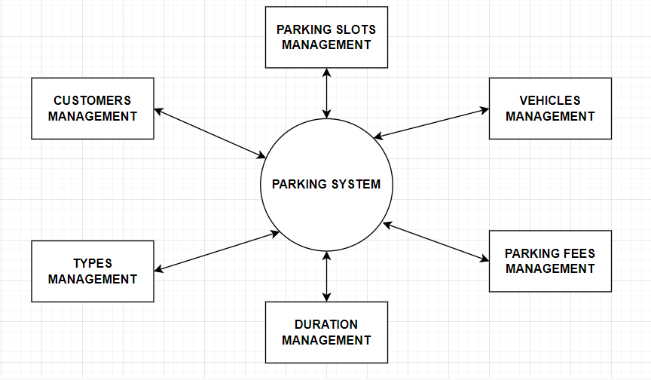

**FIRST LEVEL:**

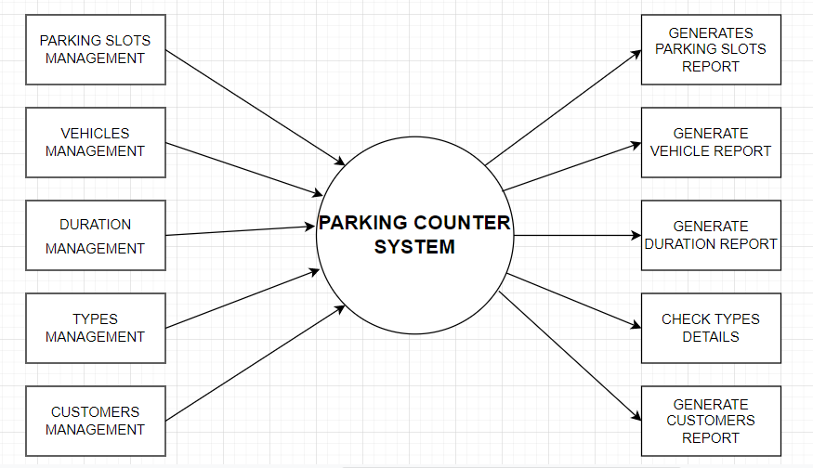

**SECOND LEVEL:**

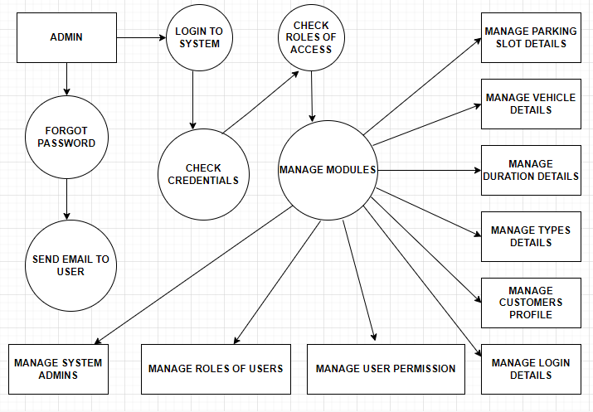

##### **RESULT ANALYSIS AND VALIDATION**

Basically , This Project is Divided into 2 Module:

* + - 1. Parking Space Picker Module
      2. Main Module

**Parking Space Picker Module:**

In this Module, We are taking Screenshot of Sample Video used here which showing all Parking slot .

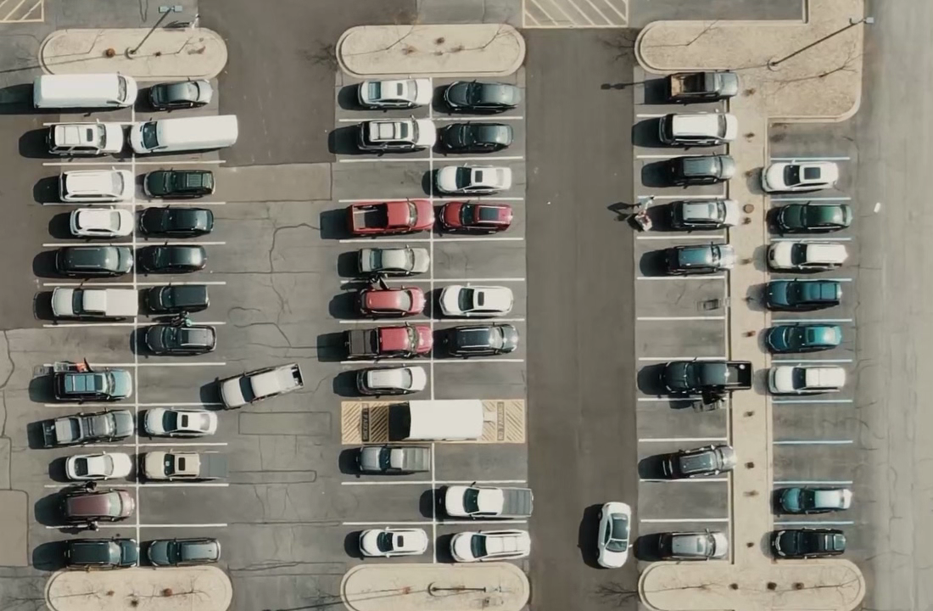

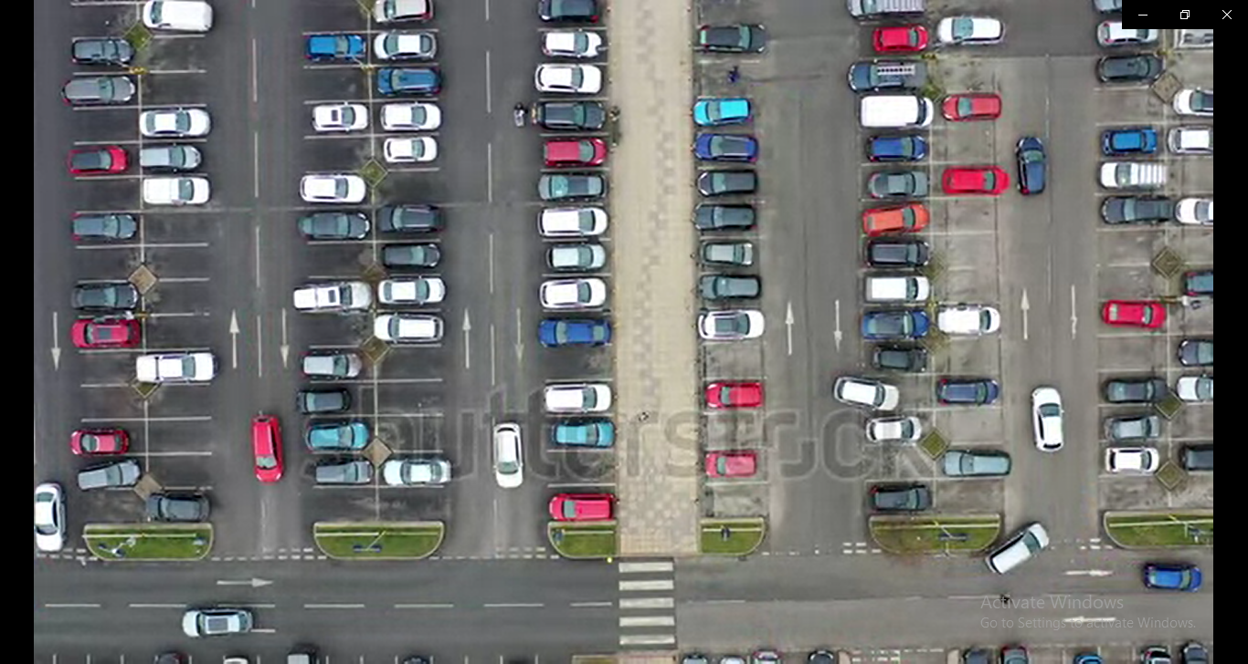

In this Image , All parking Slots Are Clearly visible for futhur Process.

Now , When This Image Encode in this Module . Complier make the cursor which make Rectangle around any Slot . we have to Make Rectangle around the Slots one by one. Just click extreme Point (x, y) of slot . it will Create the Rectangle around the Slot .

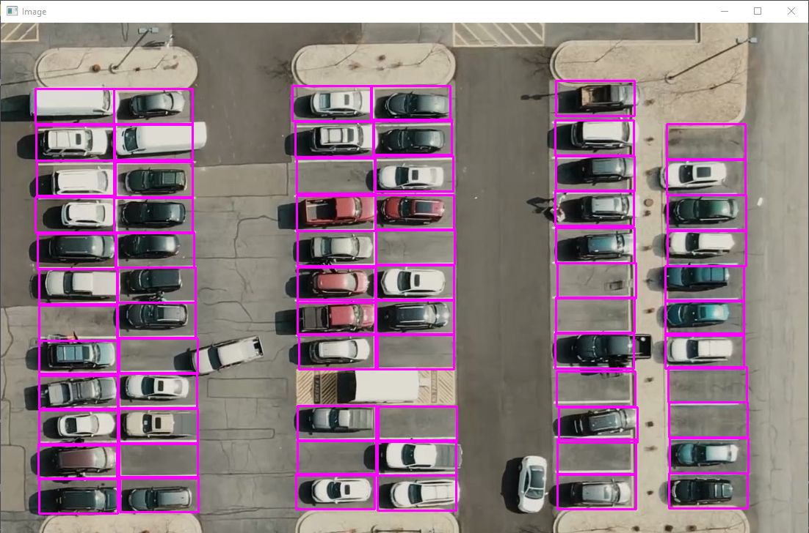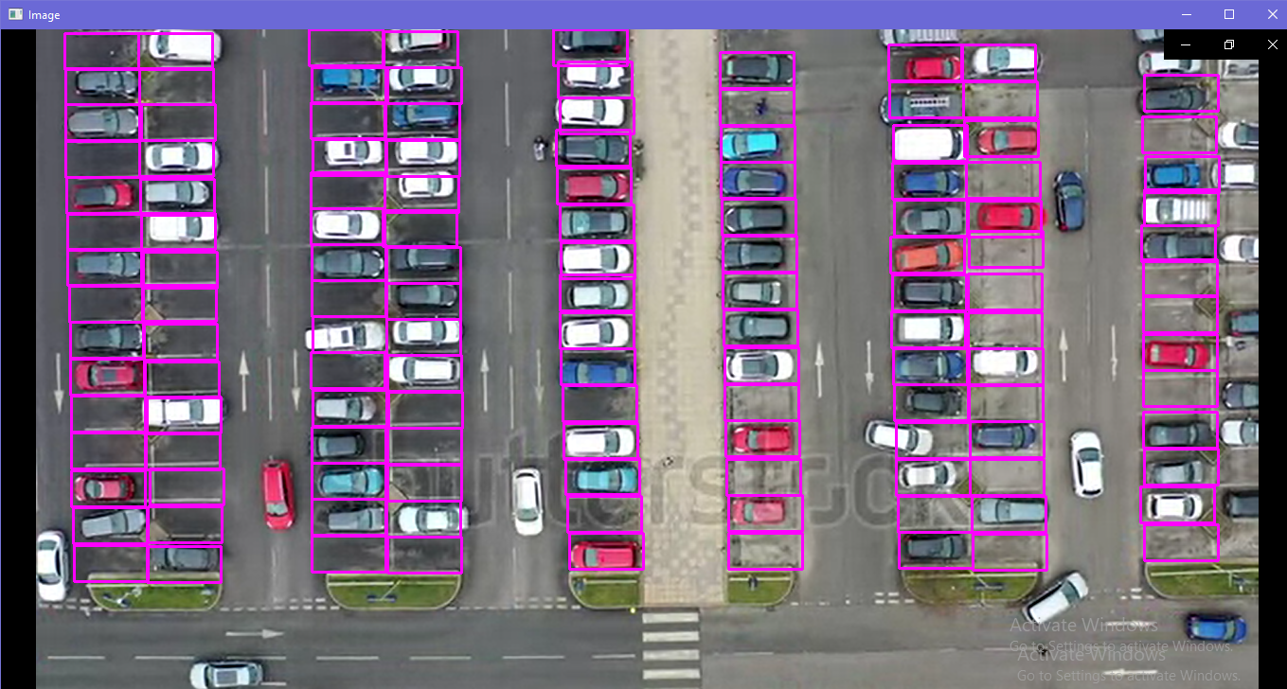

After This , Complied File is Store in the Device Having Rectangular Slot .

It Will import in Main Module.

In this Module , Firstly All the Slots Are comes under Image Crop Procedure which will Separate all the Slots.

Then Cropped Image Will go in Image Blur and Grey Scale Procedure to Make the Pixel Visible .

Here , We set The Pixel to 900, If the Slot cropped Image Pixel is Less than 900 Then the Slot is Empty and if Cropped image Pixel is greater Than 900 then the Slot is Full i.e Slot is having big Car Like Object.

After This Procedure Will go in Last Process which is FreeCounter it Will Increment the Counter If Cropped Image is Empty and It Show on The Display.



**Result:**

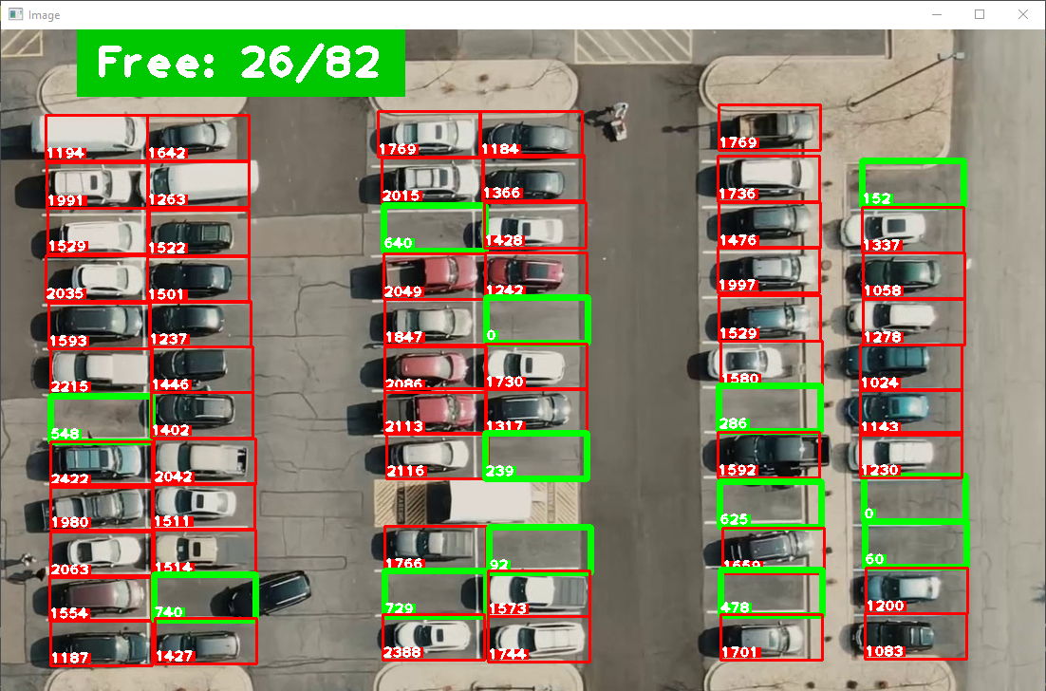

**Discussion and report/results analysis**

Parking is one of the major problems that is created by the increasing road traffic. It is an impact of transport development. The availability of less space in urban areas has increased the demand for parking space especially in areas like Central business district. This affects the mode choice also. This has a great economical impact.

On street parking means the vehicles are parked on the sides of the street itself. This will be usually controlled by government agencies itself. Common types of on-street parking are as listed below. This classification is based on the angle in which the vehicles are parked with respect to the road alignment. As per IRC the standard dimensions of a car is taken as 5× 2.5 meters and that for a truck is 3.75× 7.5 meters.

Parking has some ill-effects like congestion, accidents, pollution, obstruction to fire-fighting operations etc.

**Congestion:** Parking takes considerable street space leading to the lowering of the road capacity. Hence, speed will be reduced, journey time and delay will also subsequently increase. The operational cost of the vehicle increases leading to great economical loss to the community.

**Accidents:** Careless maneuvering of parking and unparking leads to accidents which are referred to as parking accidents. Common type of parking accidents occur while driving out a car from the parking area, careless opening of the doors of parked cars, and while bringing in the vehicle to the parking lot for parking.

**Environmental pollution**: They also cause pollution to the environment because stopping and starting of vehicles while parking and unparking results in noise and fumes. They also affect the aesthetic beauty of the buildings because cars parked at every available space creates a feeling that building rises from a plinth of cars.

**Obstruction to fire fighting operations:** Parked vehicles may obstruct the movement of firefighting vehicles. Sometimes they block access to hydrants and access to buildings.

**Parking surveys**

Parking surveys are conducted to collect the above said parking statistics. The most common parking surveys conducted are in-out survey, fixed period sampling and license plate method of survey.

**In-out survey**

In this survey, the occupancy count in the selected parking lot is taken at the beginning. Then the number of vehicles that enter the parking lot for a particular time interval is counted. The number of vehicles that leave the parking lot is also taken. The final occupancy in the parking lot is also taken. Here the labor required is very less. Only one person may be enough. But we wont get any data regarding the time duration for which a particular vehicle used that parking lot. Parking duration and turn over is not obtained. Hence we cannot estimate the parking fare from this survey. For quick survey purposes, a fixed period sampling can also be done. This is almost similar to in-out survey. All vehicles are counted at the beginning of the survey. Then after a fixed time interval that may vary between 15 minutes to i hour, the count is again taken. Here there are chances of missing the number of vehicles that were parked for a short duration.

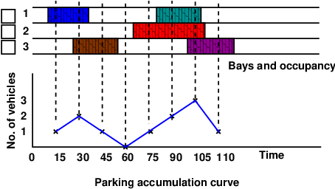

**CONCLUSION:**

The main purpose of this report is to study and analyze the

parking monitoring and control system to count the number of cars

entering and leaving a parking and provide information about free

parking spaces. We will use image processing techniques to find the

total number of cars can be parked in the area and how many vacant

slots left to be parked.

The occupancy count in the selected parking lot is taken at the

beginning. Then the number of vehicles that enter the parking lot for a

particular time interval is counted. The number of vehicles that leave

the parking lot is also taken. The final occupancy in the parking lot is

also taken. Here the labor required is very less. Only one person may

be enough. But we won’t get any data regarding the time duration for

which a particular vehicle used that parking lot. Parking duration and

turn over is not obtained. Hence we cannot estimate the parking fare

from this survey. For quick survey purposes, a fixed period sampling

can also be done. This is almost similar to in-out survey. All vehicles

are counted at the beginning of the survey. Then after a fixed time

interval that may vary between 15 minutes to i hour, the count is again

taken. Here there are chances of missing the number of vehicles that

were parked for a short duration.

**References:**

1. Tobing, Aldo. (2021). EVALUATION OF PARKING SPACES AT THE CLEANERS. CERUCUK. 5. 135. 10.20527/crc.v5i2.4318.
2. Langegger, Sig. (2017). Park Space. 10.1007/978-3-319-41177-4_8.
3. Cempírek, Václav & Turek, Michal & Kalupová, Blanka & Šaradín, Pavel. (2022). Demand forecast for parking spaces and parking areas in Olomouc. Open Engineering. 12. 11-16. 10.1515/eng-2022-0002.
4. Shidian, ma & Fang, Weifeng & Jiang, Haobin & Han, Mu & Li, Chenxu. (2021). Parking Space Recognition Method Based on Parking Space Feature Construction in the Scene of Autonomous Valet Parking. Applied Sciences. 11. 2759. 10.3390/app11062759.
5. Brozova, Helena & Ruzicka, Miroslav. (2020). THE PREDICTION OF PARKING SPACE AVAILABILITY. Transport. 35. 462-473. 10.3846/transport.2020.14016.